**Net Provisioning**

**NetProvisioning servers are: *msp001a.******sfdc.sbc.com*, *msp002a.******sfdc.sbc.com*, *msp003a.******sfdc.sbc.com*. NOTE: only msp003a is used and IS the production server. While msp001a and msp002a are suppose to be mirrors of msp003a, I have never been able to positively confirm this. The test server is *csdev61.sbc.com*.**

**User for production is syadm1, user for test is syadm4**

**Current DBAs are: Vikrant Supehia (vs0906) as an Primary DBA and Sudarshan Daga (sd721t) as backup DBA**

**There are pdf documents for using the admin gui, basic service provisioning, admin guide, and user guide in the shared network drive under NetP, although we do not do any provisioning, they are there should someone need them.**

**There are instructions for starting and stopping the application. They are self-explanatory.**

**Required tools:**

**HP Unified Functional Testing - this is a key stoke and mouse click capturing program.**

**Oracle**

**Shell**

**Perl**

**Unix utilities.**

**The HP UFT tool is run once a day, on a weekday basis. Its OK to miss a day or two… as there is little change in the network, but it is a good idea to run it as NetP database could loose sync with network configuration if I is allowed to go to long with out updating.**

**The process requires one script which should show up in the application when you start the UFT as shown:**

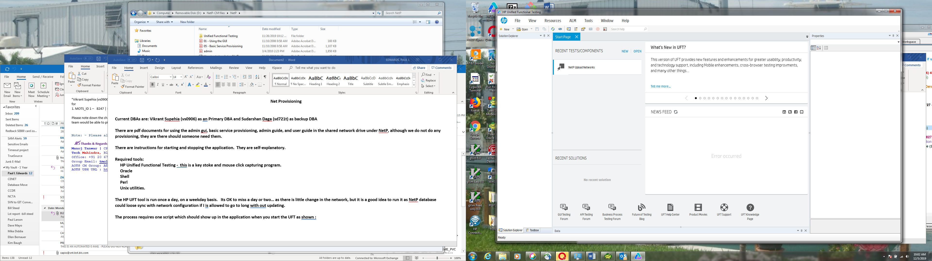

**Select the file and it will load the UFT. The resulting screen will look like this:**

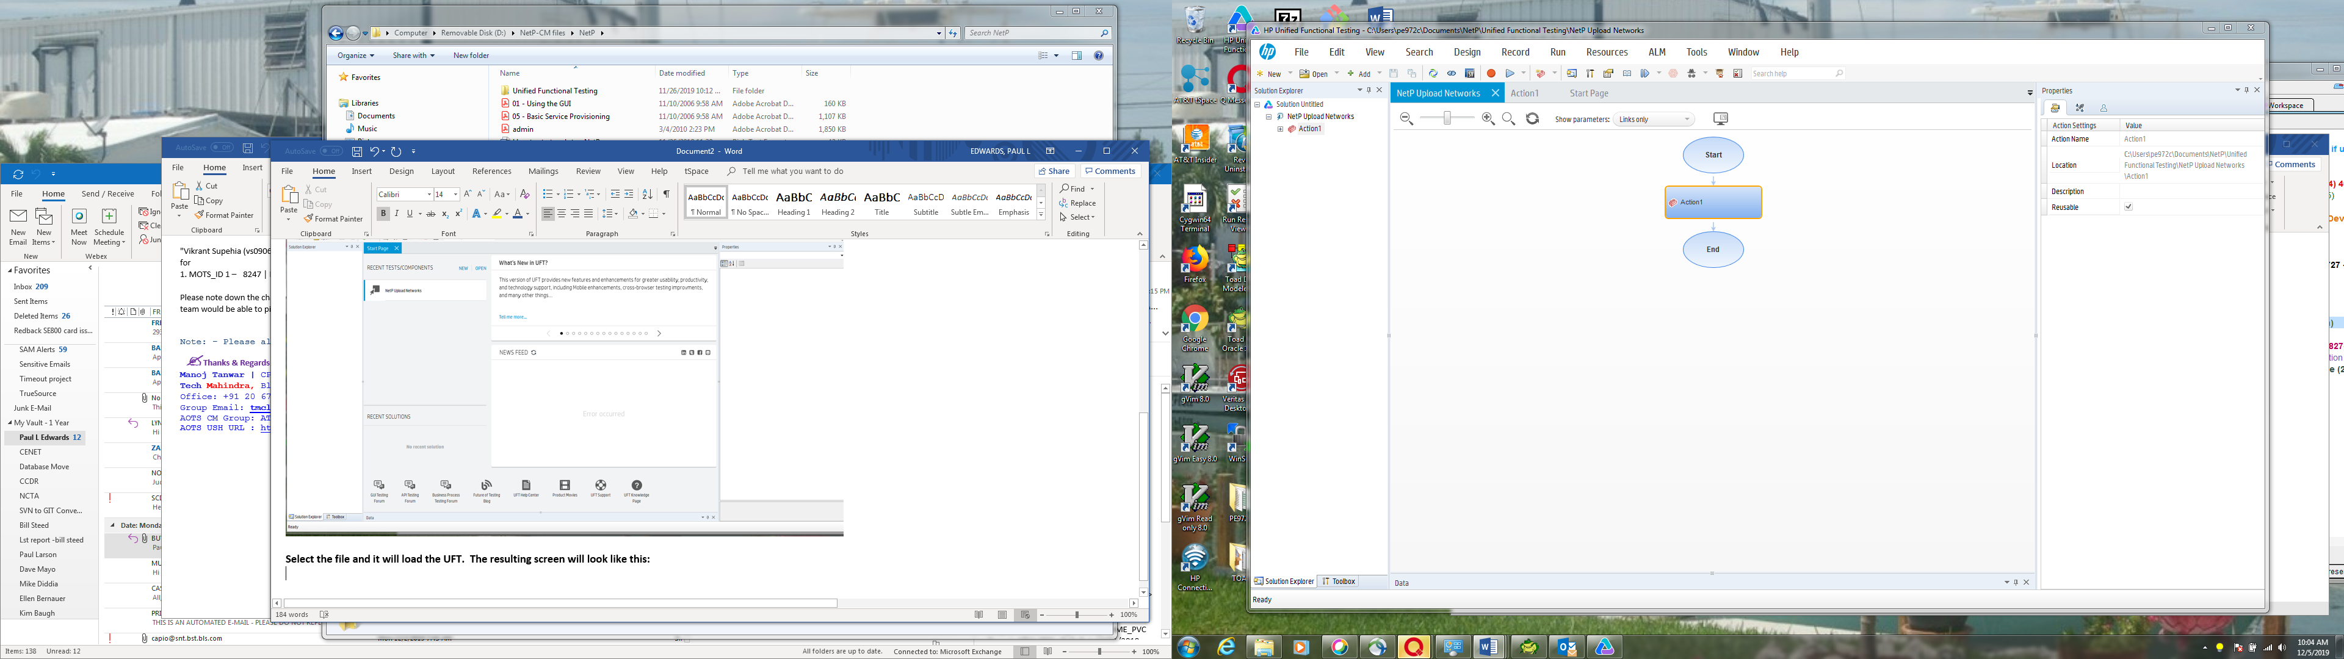

**Click on the blue right hand pointing icon to run the script, you will be asked to confirm the request in the next screen**

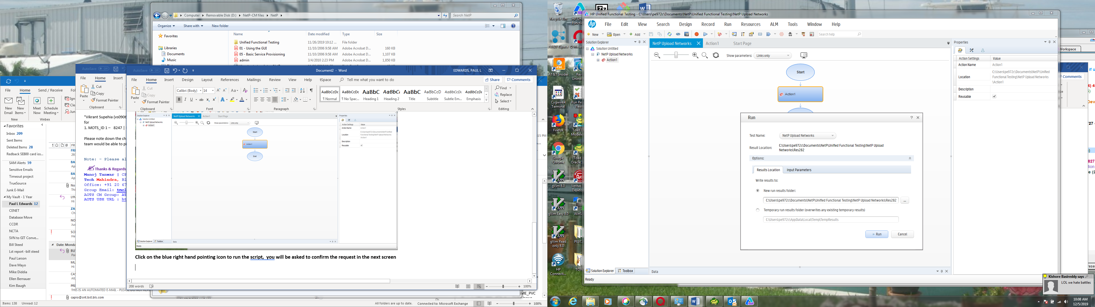

**Click on the Run button. Once the process is started you cannot use your keyboard or mouse. The process will take 2 to 5 minutes to complete**

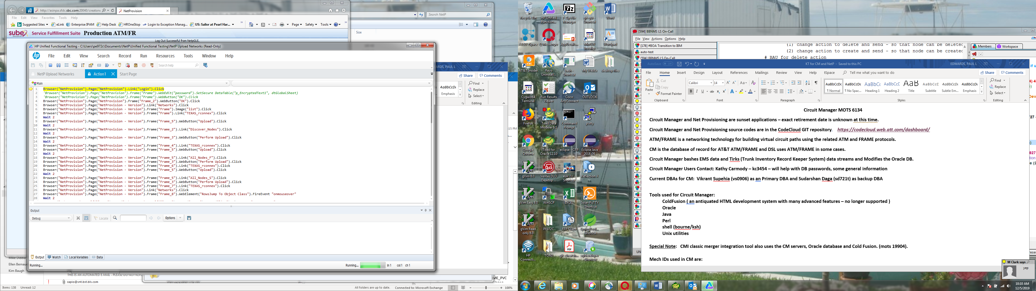

**The script that is being run will appear for a moment. Note that there is a line number showing .. yellow arrow. This is the line the script is currently executing, and it should execute 93 lines. If it does you can feel safe it ran as expected. Once the script starts, the NetP gui will partially cover the script, and you can see the gui change as if you were manually executing each step. Below is line 9 being executed.**

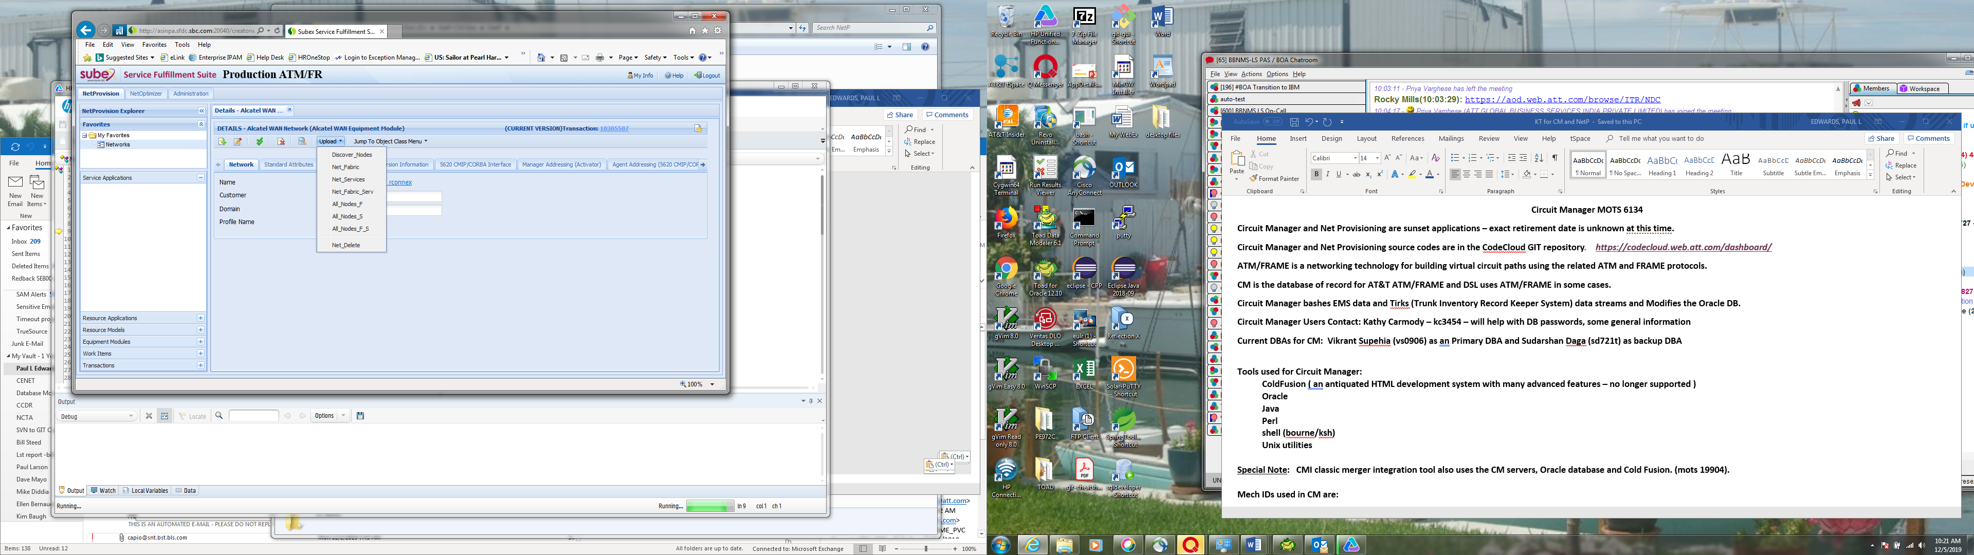

**Once the script has completed, you will get one final screen as below. The error that it is complaining about is caused by the new global log in, which requires an additional mouse click that is not in the script. It should be possible to record the first few steps and edit the script, but I was not willing to take that chance. The script completes all its steps, so this isn’t causing any problems.**

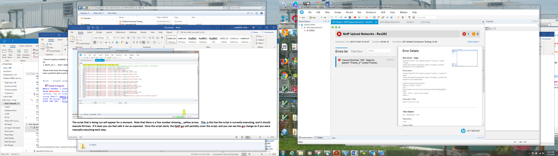

**The NetProvisioning gui link is:** [***http://asinpa.sfdc.sbc.com:20040/creatorweb/common/login.jsp?expired=true***](http://asinpa.sfdc.sbc.com:20040/creatorweb/common/login.jsp?expired=true) **and looks like this after the global login:**

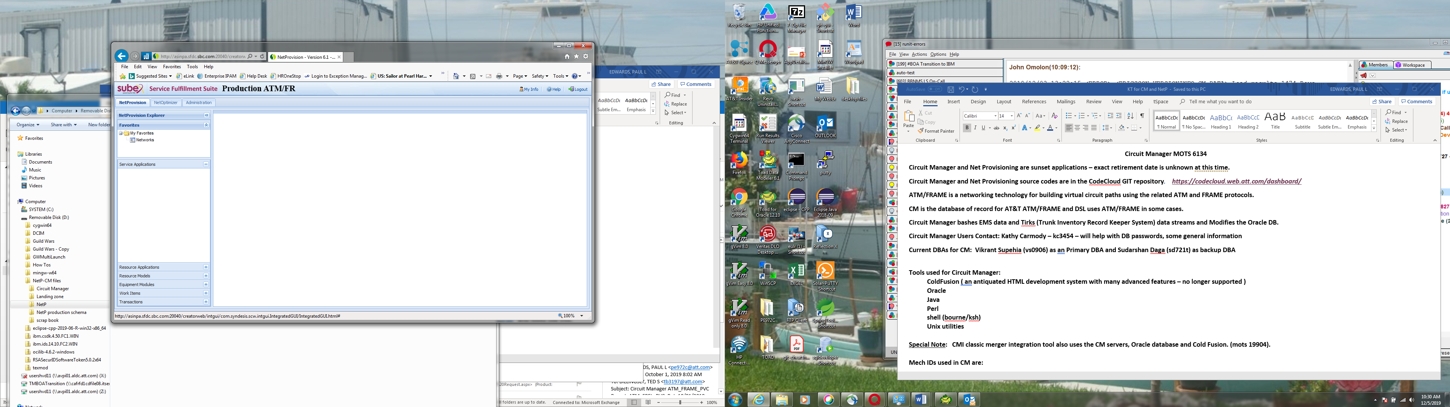

**I have never had a need to use this gui.**

**Landing Zone**

**Landing zone production server is *zlp07229.vci.att.com*. There is no test server for landing zone. The DR server for landing zone is *zlp07229.vci.att.com*.**

**Requires very little support. It is an ancillary support file server**

**Roles:**

**Application Team Lead/Requirements Lead, Landing Zone Server, MOTS 25091**

**In order to support the application, you must belong to this AT&T Role:**

|  |  |
| --- | --- |
| **ROLE NAME** | **landing_zone_admin** |
| **Description:** | **role to manage access to landing zone file server security.** |

**Responsibilities:**

1. **Add and remove file access for remote AT&T MechID or UUID users using SSH tools such as sshkey-gen and by maintaining the ~/.ssh/authorized_keys files for the 5 MechIDs used by the LZ server.  Work with AT&T users to add the required SSH public keys to enable the pushing or pulling of files from the LZ.**
2. **Maintain a current list of AMS servers that provide information on all the servers that can provide the expected set of /opt/Alcatel/AMS/current_DB* files.**
3. **Maintain the scripts that  validate the expected /opt/Alcatel/AMS/current_DB* files and that will attempt to locate and pull fresh copies for any AMS files that are damaged or missing.  These scripts also log success and failure and sent alerts when mandatory files are missing.**
4. **Work with AT&T U-Verse Tier 1 Support if mandatory AMS files are missing for 3 consecutive days.**
5. **Maintain the code cloud GIT version control repository, landingz.** 
   1. **All  file changes are managed with GIT,**
6. **Monitor the crontab processes for the 5 LZ MechID accounts.  Make any fixes or adjustments required.**